Server-ESP Communication report made by: Abdallah Youssef
Introduction:
In This report we will discuss the server-ESP communication in our project (GREENOVA)
Overview:
the ESP32-CAM microcontroller captures images of the waste inside the bin. These images are transmitted to a Flask web server running on a local computer for processing. The server analyzes the image and sends a response back to the ESP32- with the detected waste type.
Libraries Used:
For the server: we will use Flask which is a lightweight python web framework that creates end point to receive images and send back results
For the ESP:
- WiFi.h: connects the ESP32 to the Wi-Fi network
- HTTPClient.h: sends HTTP POST requests to the Flask server and receives responses.
Sample Code:
ESP Arduino Code:
#include "esp_camera.h"
#include <WiFi.h>
#include <HTTPClient.h>

// ===== WIFI =====
const char* ssid = "AHMED";
const char* password = "KLM1375H";

// ===== NGROK UPLOAD URL =====
// MUST end with /upload
const char* uploadUrl = "https://true-crabs-march.loca.lt/upload";

// ===== CAMERA PINS (ESP32 WROVER KIT) =====
#define PWDN_GPIO_NUM -1
#define RESET_GPIO_NUM -1
#define XCLK_GPIO_NUM 21
#define SIOD_GPIO_NUM 26
#define SIOC_GPIO_NUM 27

#define Y9_GPIO_NUM 35
#define Y8_GPIO_NUM 34
#define Y7_GPIO_NUM 39
#define Y6_GPIO_NUM 36
#define Y5_GPIO_NUM 19
#define Y4_GPIO_NUM 18
#define Y3_GPIO_NUM 5
#define Y2_GPIO_NUM 4
#define VSYNC_GPIO_NUM 25
#define HREF_GPIO_NUM 23
#define PCLK_GPIO_NUM 22

void setup() {
Serial.begin(115200);
Serial.println("Booting...");

// ===== CAMERA CONFIG =====
camera_config_t config;
config.ledc_channel = LEDC_CHANNEL_0;
config.ledc_timer = LEDC_TIMER_0;
config.pin_d0 = Y2_GPIO_NUM;
config.pin_d1 = Y3_GPIO_NUM;
config.pin_d2 = Y4_GPIO_NUM;
config.pin_d3 = Y5_GPIO_NUM;
config.pin_d4 = Y6_GPIO_NUM;
config.pin_d5 = Y7_GPIO_NUM;
config.pin_d6 = Y8_GPIO_NUM;
config.pin_d7 = Y9_GPIO_NUM;
config.pin_xclk = XCLK_GPIO_NUM;
config.pin_pclk = PCLK_GPIO_NUM;
config.pin_vsync = VSYNC_GPIO_NUM;
config.pin_href = HREF_GPIO_NUM;
config.pin_sscb_sda = SIOD_GPIO_NUM;
config.pin_sscb_scl = SIOC_GPIO_NUM;
config.pin_pwdn = PWDN_GPIO_NUM;
config.pin_reset = RESET_GPIO_NUM;
config.xclk_freq_hz = 20000000;
config.pixel_format = PIXFORMAT_JPEG;

config.frame_size = FRAMESIZE_QVGA;
config.jpeg_quality = 12;
config.fb_count = 1;

if (esp_camera_init(&config) != ESP_OK) {
Serial.println("❌ Camera init failed!");
return;
}
Serial.println("📷 Camera started.");

// ===== WIFI =====
WiFi.begin(ssid, password);
Serial.print("Connecting to WiFi");
while (WiFi.status() != WL_CONNECTED) {
Serial.print(".");
delay(400);
}
Serial.println("\n✔ WiFi connected");
}

void loop() {

Serial.println("📸 Capturing image...");
camera_fb_t *fb = esp_camera_fb_get();

if (!fb) {
Serial.println("❌ Capture failed");
delay(2000);
return;
}

Serial.printf("Image size: %d bytes\n", fb->len);

// ===== BYPASS SSL HANDSHAKE =====
WiFiClientSecure client;
client.setInsecure(); // <<< THIS BYPASSES CERTIFICATE VALIDATION

HTTPClient http;
http.begin(client, uploadUrl);

// =========================================================
// === AUTHENTICATION HEADER ADDED HERE ====================
// =========================================================
// Base64-encoded value for credentials: :156.202.45.89
const char* authHeaderValue = "Basic OjE1Ni4yMDIuNDUuODk=";
http.addHeader("Authorization", authHeaderValue);
// =========================================================

http.addHeader("Content-Type", "image/jpeg");

// Send POST request
int response = http.POST(fb->buf, fb->len);

Serial.print("Server Response: ");
Serial.println(response);

if (response > 0) {
Serial.println(http.getString());
} else {
Serial.println("❌ Failed to send POST");
}

http.end();
esp_camera_fb_return(fb);

delay(5000); // wait 5 seconds before next photo
}

For tunneling I used local tunneling because its free and work perfectly with ESP32 , other tunneling providers like NGROK Isn’t compatible with ESPs due to conflicts happen in the TLS certification between them
Here is the Local Tunneling:
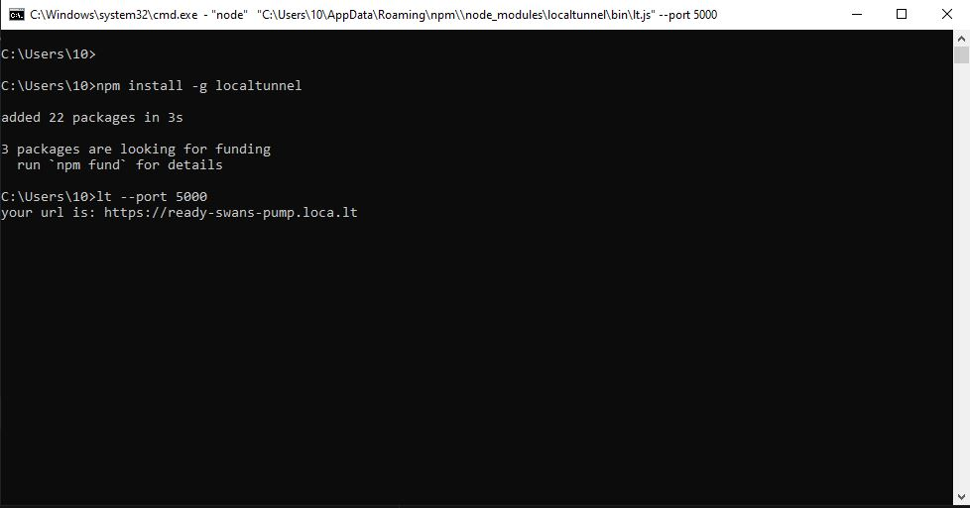

Flask server code:
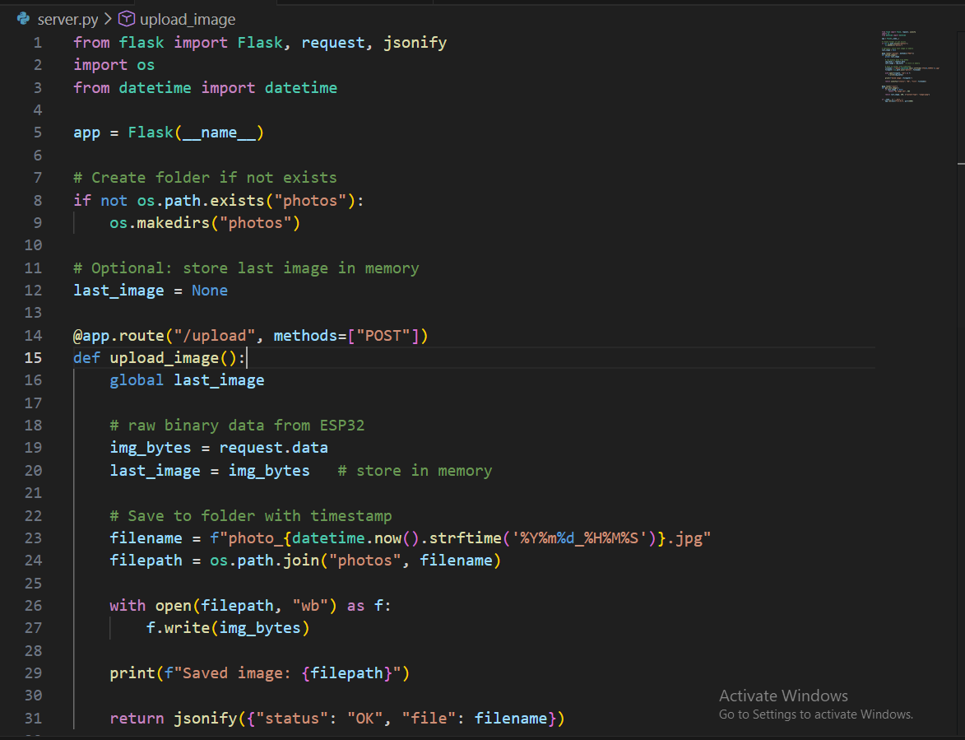

This code Establish a flask web server on port 5000 to Receive Pictures sent via POST by the esp 32 Then Saving the pictures to a folder

Output:
After running the Flask server :
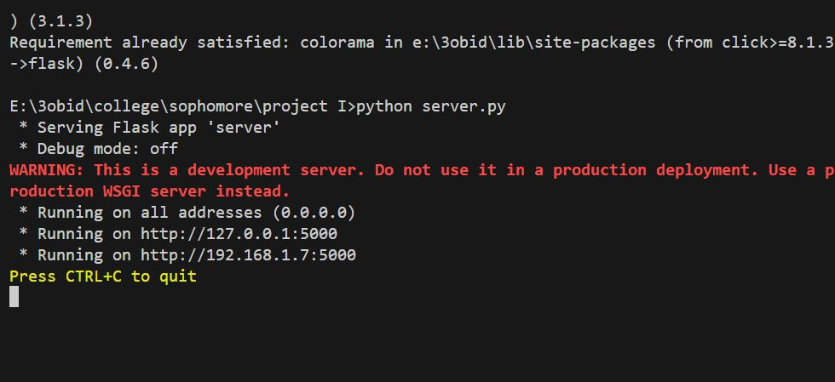
Then we enabled tunneling:


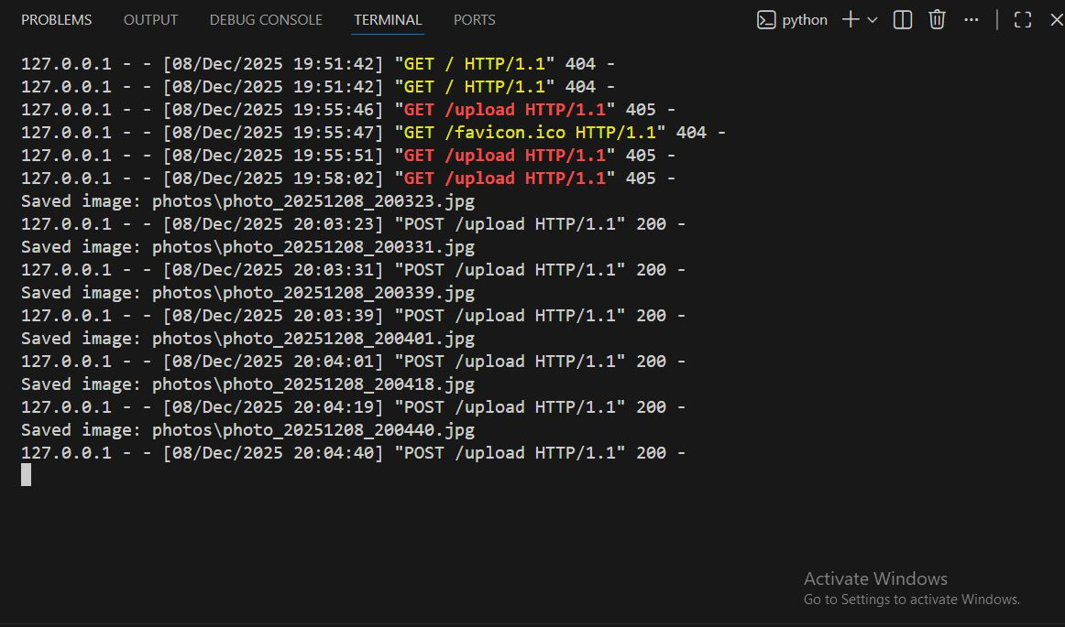
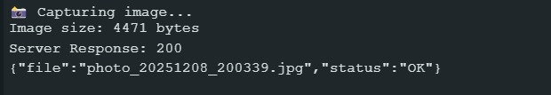
Then the Esp will start capturing image and sending it into our webserver

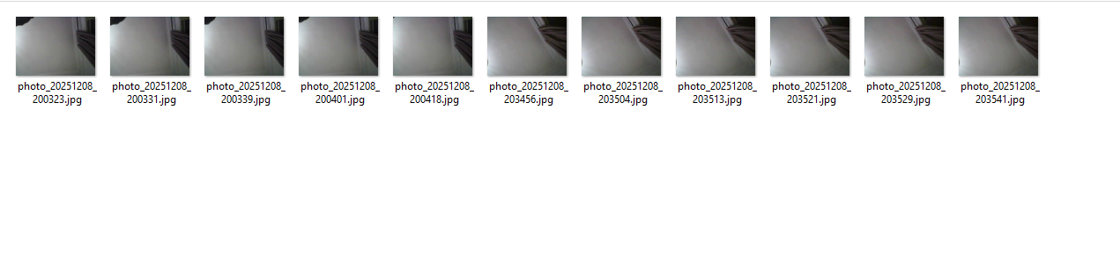
Future steps:
Right now the ESP is configured to send a picture every 1 minute , the next step is to install A PIR Sensor to send a picture only when there is an object placed (the esp will start sending once an object is placed in the trash)

